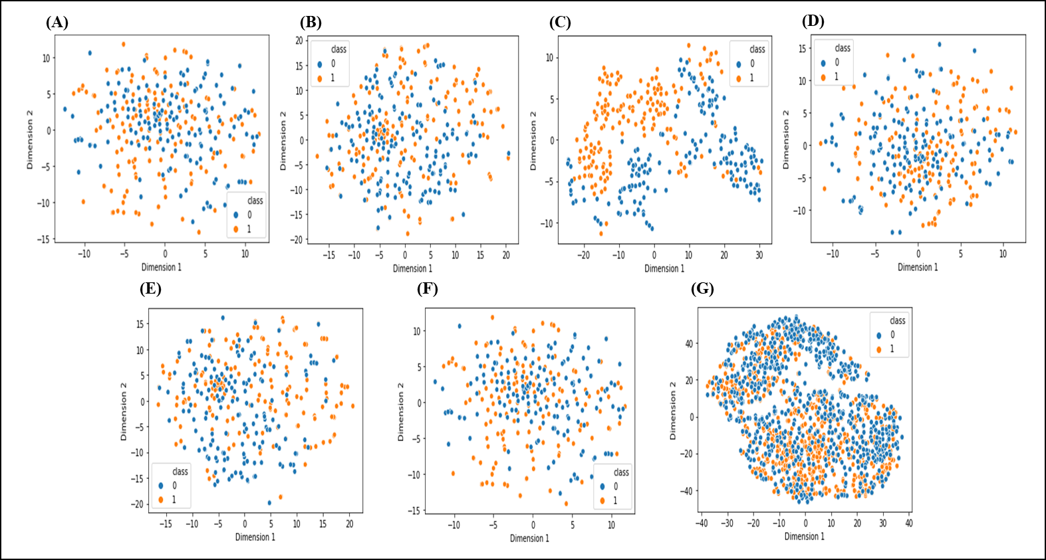
Supplementary Fig. 1. Single encoding features and fusion feature visualization through t-SNE. Single encoding of AAC (A), Single encoding of CKSAAP (B), Single encoding of PAAC (C), Single encoding of CTD (D), Single encoding of GD (E), Single encoding of NMBroto (F) and fusion encodings (G). In this figure, ‘1’ in orange color characterizes lipocalin and ‘0’ in blue color displaying non-lipocalins.

Supplementary Table 1. Performance of single-encodings and fusion models before feature selection on different machine learning classifiers.
Support Vector Machine Random Forest Naïve Bayes Ada Boost
Descriptor | Acc | Sp | Sn | MCC | AUC | Acc | Sp | Sn | MCC | AUC | Acc | Sp | Sn | MCC | AUC | Acc | Sp | Sn | MCC | AUC
AAC | 53.19 | 51.80 | 97.60 | 0.136 | 0.531 | 78.95 | 78.60 | 79.70 | 0.579 | 0.873 | 69.50 | 68.00 | 74.10 | 0.392 | 0.754 | 69.03 | 70.60 | 65.60 | 0.382 | 0.785
CKSAAP | 55.55 | 51.70 | 85.40 | 0.117 | 0.555 | 84.39 | 80.90 | 90.10 | 0.692 | 0.930 | 81.56 | 76.40 | 89.50 | 0.644 | 0.840 | 82.03 | 85.80 | 76.90 | 0.644 | 0.894
CTD | 52.71 | 51.50 | 98.10 | 0.126 | 0.526 | 72.57 | 71.80 | 74.50 | 0.452 | 0.795 | 64.53 | 61.90 | 75.90 | 0.298 | 0.722 | 62.64 | 61.30 | 68.90 | 0.255 | 0.704
Geary | 60.75 | 57.10 | 87.30 | 0.253 | 0.607 | 82.50 | 80.80 | 85.40 | 0.651 | 0.900 | 78.01 | 76.90 | 80.20 | 0.561 | 0.850 | 69.56 | 72.70 | 62.71 | 0.394 | 0.774
NMBroto | 52.48 | 51.40 | 88.10 | 0.118 | 0.524 | 78.48 | 78.10 | 78.20 | 0.570 | 0.880 | 68.08 | 64.50 | 80.70 | 0.373 | 0.768 | 71.86 | 74.90 | 66.00 | 0.441 | 0.806
PAAC | 85.81 | 83.00 | 90.10 | 0.719 | 0.858 | 86.05 | 82.80 | 91.00 | 0.725 | 0.933 | 68.32 | 61.70 | 87.20 | 0.448 | 0.864 | 81.32 | 77.10 | 89.20 | 0.634 | 0.863
Fusion | 86.11 | 93.10 | 90.40 | 0.853 | 0.934 | 92.17 | 92.33 | 93.44 | 0.889 | 0.956 | 88.11 | 88.10 | 90.18 | 0.732 | 0.924 | 88.89 | 87.80 | 89.77 | 0.768 | 0.916

